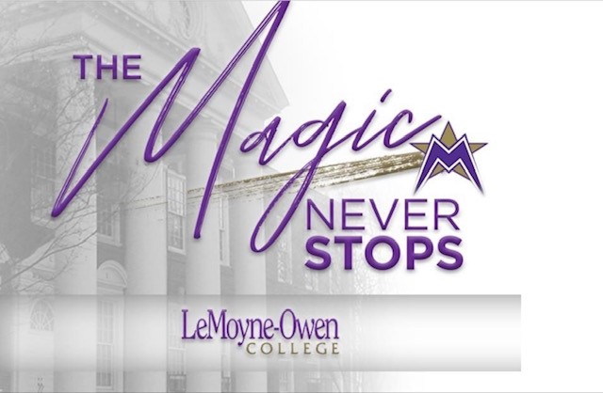
LeMoyne-Owen College
Budget Planning Form 2025-2026

Destination 2023 Outcome(s): | See Destination 2023 Strategic Plan (e.g., Faculty and Academic Programs)
Division/Department: Institutional Research, Effectiveness & Compliance | Budget Period: 2025-2026
Name: XXXXXX XXXXXX | Report Date: 2/XX/2025
Title: Director of Institutional Research, Effectiveness and Compliance

Objectives | Initiatives | Cost
Assist faculty in gaining a better understanding of how well they are meeting the learning outcomes of their students. | Renew Annual Subscription for SmartEvals | $ XXX
Integrate accreditation, assessment, planning,  Credentialing and budgeting at LOC. | Renew Annual Subscription for SPOL | $ XXX
 | TOTAL | $ XXX

